PHYS 104 Lab 2 STANDING WAVES ON A STRING

Introduction

In this lab you will study standing waves on a string. You will generate waves on a string using a **vibrator** powered by **Data Studio’s Interface Box Output,** which will allow you to vary the *frequency* of vibrationsuntil the standing waveis generated. You’ll use an **Excel** spreadsheet to evaluate your results.

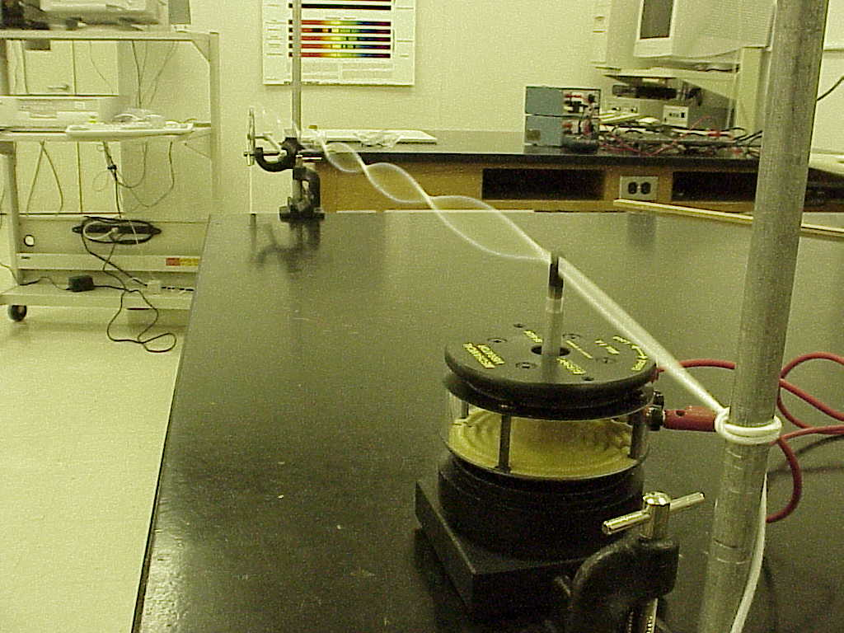

**Figure 1.**

A **vibrator** (shown in figures 1 and 2) can be operated at varying frequencies at which it shakes the string. If the *tension* created by the *mass* attached to the string is correct then the string will be excited into standing wave (as shown).

Theory

Standing waves are a result of interference between two waves traveling in opposite directions. The cause of standing waves is the resonance due to interference between waves reflected back and forth at the resonant frequency.

**Figure 2.**

**Figure 1.**

For a string with two fixed ends the wavelengths of the harmonics are given by

 (1)

 the wavelength of the fundamental.

Combining equation (1) with the wave equation

 (2)

gives us the following expression for the frequency spectrum of the harmonics

 (3)

 the frequency of the fundamental.

The velocity of a wave on a sting is dependent on the amount of tension that the string is under and on the mass density of that string in the following way:

 (4)

here F*T* denotes the *tension* on the string (measured in Newtons) and ** is the *mass density* of the string *µ* = *m/L* (*mass* divided by *length*).

Procedure

1. Open the **Data Studio** and **'Create Experiment.'**. In the **'Experiment Setup'** select **'Output'** by double-clicking it. You should see a display that looks like figure 2 on page 3.
2. Physically connect the **vibrator** to the output of the **Interface Box** with banana cables.
3. Tie one end of the string to the vertical post (the one without a pulley), and hang 200g mass on the other end of it after placing it over a pulley (see figures1 and 2). Place the **vibrator** next to the post (the one without a pulley) and insert the string to the slot on its top. Adjust the position of the string so that it is horizontal stretching from post through the **vibrator**, and over the pulley.
4. In the **'Signal Generator Display'** select sine wave.
5. In the **'Signal Generator Display'** set the amplitude to 5V. Make sure that the **'AUTO'** button is not selected for the signal generator.

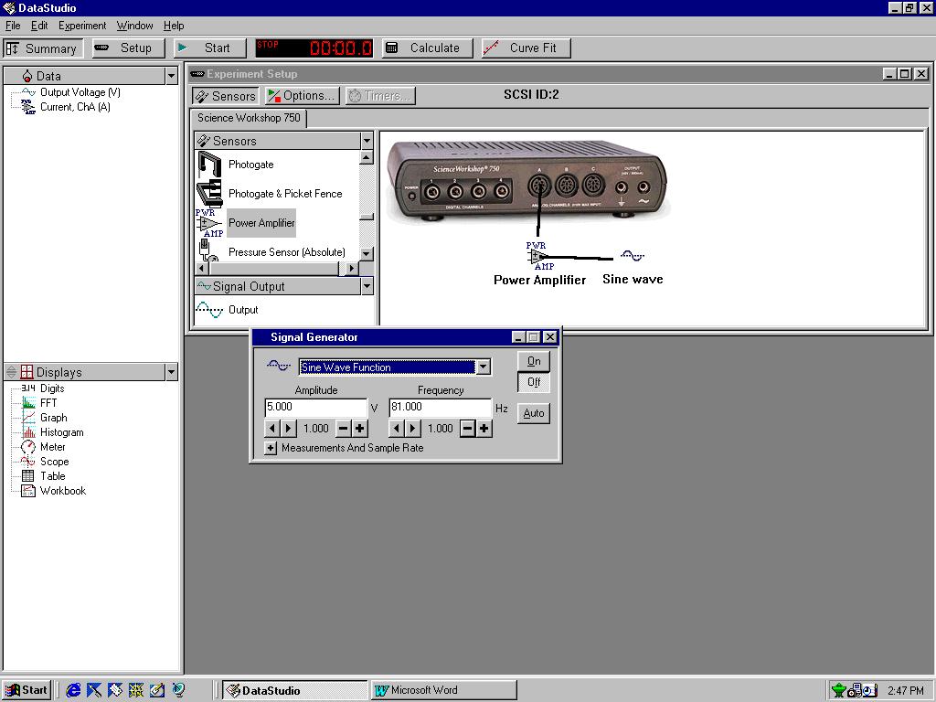

**Figure 2.**

1. Start at a frequency of 5 Hz and increase it in increments of 1 Hz looking for resonance frequencies. Once the string is close to generating a standing wave, change the stepping increment to 0.1 Hz and fine-tune your frequency observing the wave. Hint: we are looking for resonant frequencies so you should look for the greatest amplitude.
2. Record the number of the anti-nodes (here 1) in your standing wave and its frequency in an **Excel** spreadsheet.
3. Repeat procedure steps 6 and 7 for standing waves with the number of antinodes *n* = 2, 3, 4…,10.
4. In **Excel** plot the frequency vs. the number of the anti-nodes. Label axis and include units.
5. Using the linear trendline in **Excel**, to fit your experimental data. Display equation and R2 on the chart. Select the option to set *y*-intercept to zero.
6. Is your data linear? Is your fit good? Discuss.
7. Why did we set *y*-intercept to zero? Discuss.
8. What physical quantity does the slope of the line represent? Did you confirm relation (3)? Discuss.
9. Examine the additional setups and discuss the effects of different string lengths and different tensions on the spectrum of the harmonics.

**Print all your data, graphs, and tables, and attach them to your report.**

**Whenever possible SAVE PAPER.**

**Delete your files from the computer.**

**Disconnect all equipment, close all applications, and log off your PC.**

**DO NOT TURN THE COMPUTER OFF.**

**Make sure you leave the classroom as you found it.**

**lab 2 Report** Name……………………………...

Name……………………………...

Name……………………………...

Introduction:

Data Presentation:

11.

12.

13.

14.

**REMINDERS:** Include units.

Make sure to attach all your data and graphs. No data = No credit

Please do not hand in the manual, just the report.

conclusion: